Joshua Peek - [jpeek6@my.gcu.edu](mailto:jpeek6@my.gcu.edu)

Project intro and notes,

I’m a Game and Simulation development major and I’m also a part of the BCI-Thought-to-Text team and my idea for my Capstone is a brain computer interface to control in-game controls for a simple video game, or a product/software for implementing this in a game (customer would be game companies looking to provide accessibility options for their player base. For my mentor I asked Dr. Artzi, as he has an interest in both AI and games, and he has accepted my request.

*Note mentor has changed to David Demland*

Light pupil vs dark pupil

Mapping a mouse control/keyboard control.

Calibration

Sip and puff on a wheelchair/the control of the joystick? Try to figure out the behaviour of the mouse and look around.

Get the sdk emotiv epoc x

https://shop.openbci.com/products/all-in-one-gelfree-electrode-cap-bundle

1. Romans
2. Apostle Paul
3. 1-425D
4. [my.gcu.edu](http://my.gcu.edu) credentials

Feasibility study:

1. intro : determine the viability of the project, what problem are you gonna solve
2. Project description: describe the project/its purpose
3. Technical feasibility: are you able to complete this project, time, money, planning and implementation.
4. Technical stack: Describe the tech you need to complete the project. How will they be acquired?
5. Operational feasibility: Explain with evidence how the team will move forward, who’s the target audience, how large, how will you test the acceptance.
6. Spreadsheet of expected costs.
   1. Costing section, Economic experts time and money?
   2. Topdown estimation? Function point analysis.
7. Detailed conclusion of the entire feasibility study.

Week 2:

Phillipians 3:12

Lab notes

The team is Joshua Peek, Kian Knudegaard, maybe someone else?

The project is BrainComputerInterface for keyboard/mouse control in a game/building an SDK that game companies could use to increase accessibility in their games.

My mentor is Dr. Artzi (maybe Demland?)

*screenshot* For ‘#9’ in place of online video, On ground submits either a picture or brief video of CLC members with a mentor within the week of the assignment.

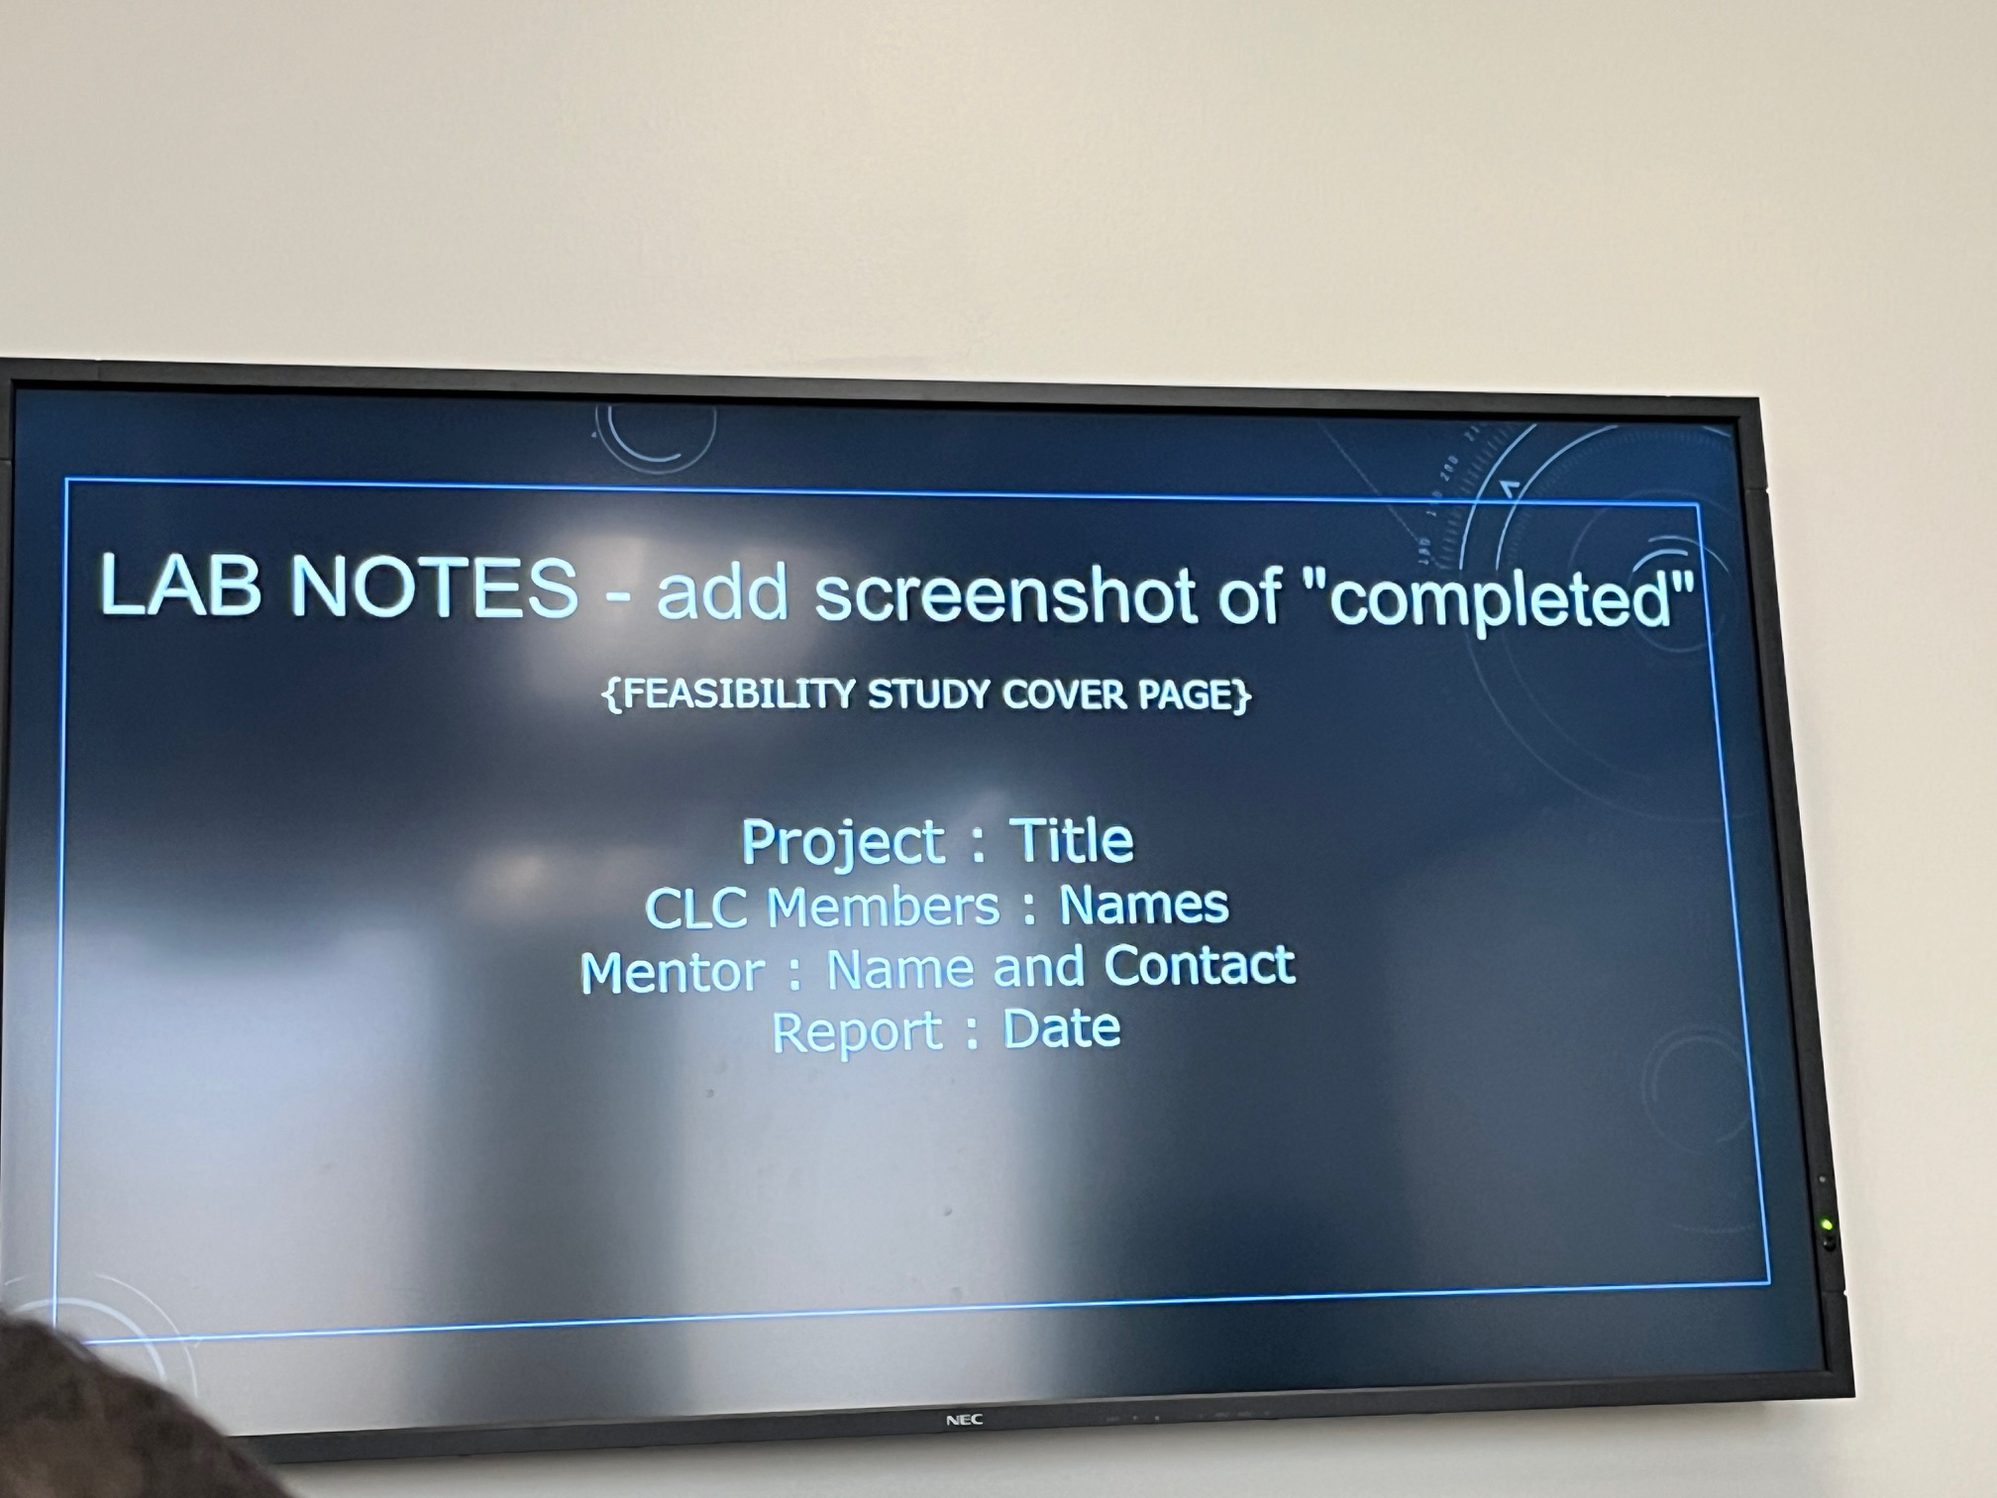

Lab Tech (a):

My personal ability to complete this capstone revolves around my experience with making Games in Unity, and My CAIR project which has given me experience with the BCI device. The project will be a combination of my experiences of the past couple of years which include the internship with CAIR and a number of classes that relate to coding, designing, and implementing games/internal components of games such as an SDK.

Tech (b):

Describe the technologies that will be required to complete the project?

I have access to the CAIR clubs BCI, as well as an EMOTIV EPOC x that I have been given permission to take and use; for that however I will need to acquire the license.

How and when will the tech be acquired?

I have the physical technology; the only issue will be acquiring the licenses through the school/for the project through the school. Using the

*9/16/25 Demland is mentor, group finalized *